<!ELEMENT element-name category>

#PCDATA - Elements with only parsed character data are declared with #PCDATA inside parentheses  
ANY - Elements declared with the category keyword ANY, can contain any combination of parsable data

child:  
* 0 lub wiecej  
+ 1 lub wiecej  
? zero lub jeden

<!ATTLIST element-name attribute-name attribute-type attribute-value>

NMTOKEN - The first character of an NMTOKEN value must be a letter, digit, '.', '-', '_', or ':'validity constraint. See example.

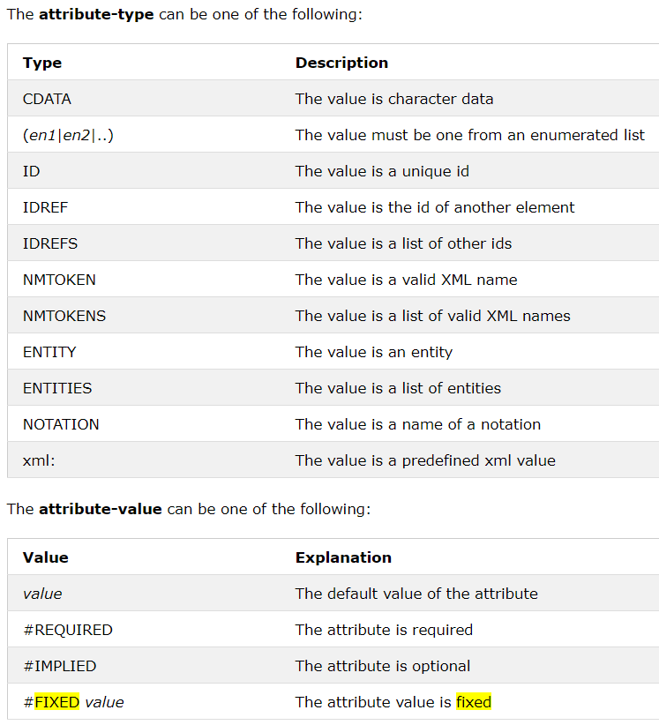

<!ENTITY entity-name "entity-value">

<!ENTITY writer "Donald Duck.">  
<!ENTITY copyright "Copyright W3Schools.">

|  |  |
| --- | --- |
| Enumerated | Enumerated attribute types allow you to make a choice between different attribute values. The first character of an Enumerated value must be a letter, digit, '.', '-', '_', or ':' |